Name Period

Homework

For use after Lesson 4.4

4.4

Find the slope and *y*-intercept of the graph of the linear equation (make sure it’s in slope-intercept form).

1.  2.  3. 

Graph the linear equation. Identify the *x*-intercept (y=0). (Use intercepts)

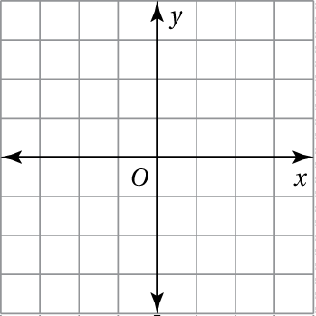 4.  5. 



 6. The equation  represents the time (in minutes) left after *x* games of a tournament (label your graph).

a. Graph the equation (use intercepts).

b. Interpret the *x*-intercept and slope.